Dominic Drury

11/21/2023

CS340

5-2 Assignment: Client-Side Authentication

NoteBook code for importing CRUD module named AnimalShelter, callback routine for instantiation of crud object, and search result for a dog named Lucy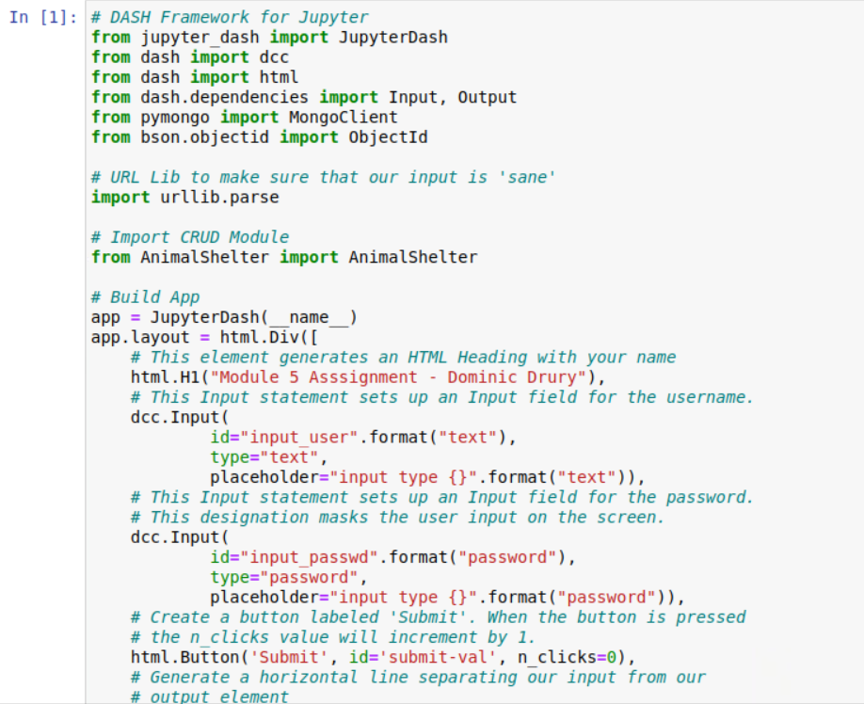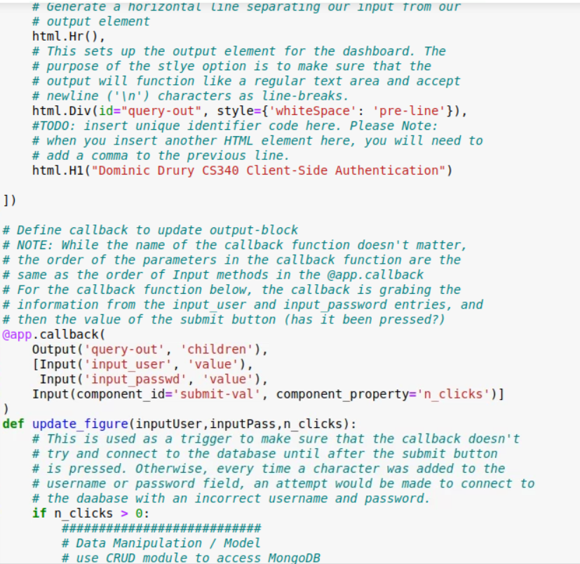

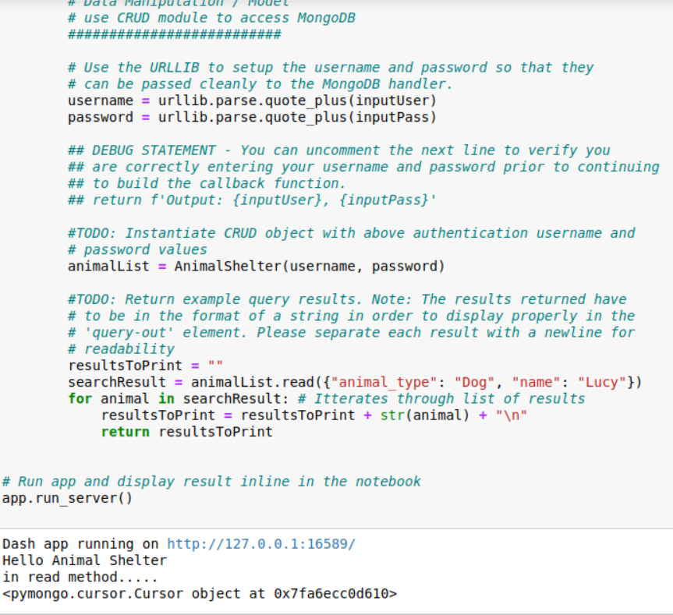

Dashboard as proof of execution

